**8-2 (Old 12-2) Solving Inequalities**

**Basic Theory**

1. If a function is continuous everywhere, at what values of x is it possible for the y-values of the function to change sign (i.e., positive to negative or vice versa)? Must the function change sign at those values? Support your argument with some sample graphs.
2. Let’s move to a function that is continuous everywhere except for vertical asymptotes. At what x-values would it be possible for the y-values of this function to change sign? Must the function change sign at those values? Support your argument with some sample graphs.
3. What must be true about the function in #1 or #2 at x-values lying between those you identified? In particular, can the function change sign at any of those “in between” x-values?
4. How does the reasoning in #1-3 build up a strategy of using a sign chart to tell when a function is positive or negative?

**Problems**

In each of the following, use sign charts to find the value(s) of x that make the given statement true. (#15-19 from S-Z 4.3). (Find some of these graphically with given graphs?) Note: Absolute value inequalities to be done in the “Distance vs. Displacement” section.

1. x - 3 > 0 6. (x-3)(x+2) < 0 7.

8. -3 9. -3

10. . -3 11. -3

12.  13. 14.

15. (x-3)(x+2) < 4 16. (x-3)(x+2) < 4x +1.

17. 18. < 0

19. (Why would it be a bad idea to multiply by $x^{2}-9$ or to “cross-multiply”? Hint: Think of what you do when solving 4x > 8 vs. -4x > 8. What to do if multiplying by something involving “x” on both sides?).

20. Find the domain of $f\left(x\right)=\sqrt{\frac{x+7}{3x-2}}$

(Note: Good exponential, log, and trig inequalities in S-Z for later Too early now).

21. (S-Z 2.4) The height h in feet of a model rocket above the ground t seconds after lift-off is given by h(t) = −5 $t^{2}$ + 100t, for 0 ≤ t ≤ 20. When is the rocket at least 250 feet off the ground?

22. (s-Z 2.4) Suppose C(x) = $x^{2}$ − 10x + 27, x ≥ 0 represents the costs, in hundreds of dollars, to produce x thousand pens. Find the number of pens which can be produced for no more than $1100.

23. (MFG 6.5): The Chamber of Commerce in River City plans to put on a Fourth of July fireworks display. City regulations require that fireworks at public gatherings explode higher than 800 feet above the ground. The mayor particularly wants to include the Freedom Starburst model, which is launched from the ground. Its height after t seconds is given by

h=f(t)=256t−16 $t^{2}$

When should the Starburst explode in order to satisfy the safety regulation?

24 (MFG 6.5): A group of cylindrical storage tanks must be 20 feet tall. If the volume of each tank must be between 500π and 2880π cubic feet, what are the possible values for the radius of a tank?

25. (MFG 6.5) Use the given graph to estimate solutions to the equation and inequality:

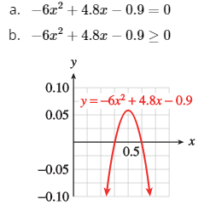

26. (ORCCA: II-250):

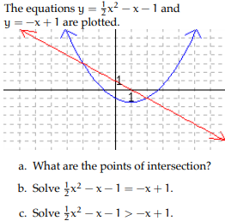

d. Solve the inequality in © by using only one graph.